Sponsorship of Moore County Women’s Amateur
August 5 and 6 2024

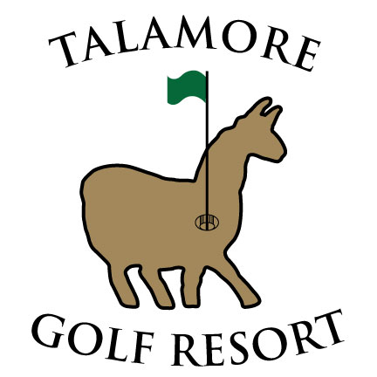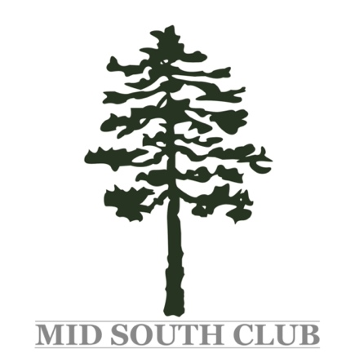

To benefit Friend to Friend, a Moore County non-profit helping survivors of domestic violence, sexual assault, and human trafficking
www.friendtofriend.me

Donors receive on-course signage, and acknowledgment
on the Moore County Women’s Amateur website
Gold $500 Green $300 Purple $150

Check made payable directly to Friend to Friend and mailed to:
Rita Roberts, 3 Wake Forest Ct., Southern Pines, NC 28387

100% of donation is tax deductible.

Company/Individual Name: _______________________________________
Check Number/Date: ________________________________________

To be included on the MCWA website, send to tstpeter261@gmail.com with the subject: MCWA Sponsor:
- Logo in JPG format with no compression
- Business website address (if applicable)
- Name of business or individual

